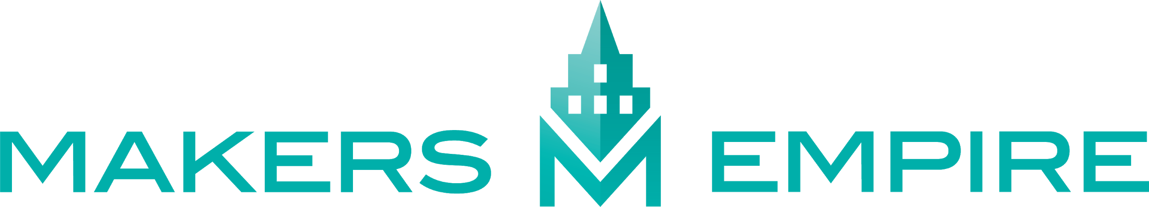
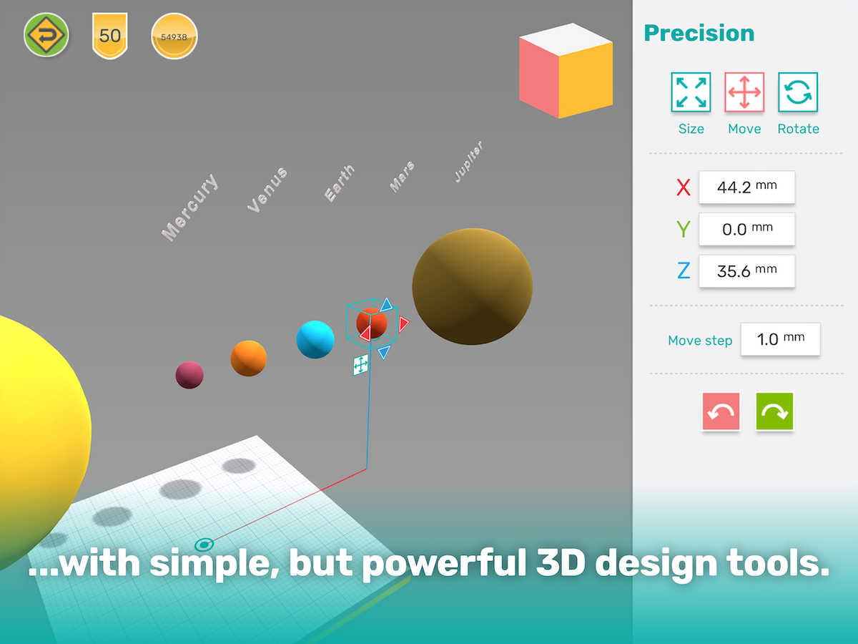
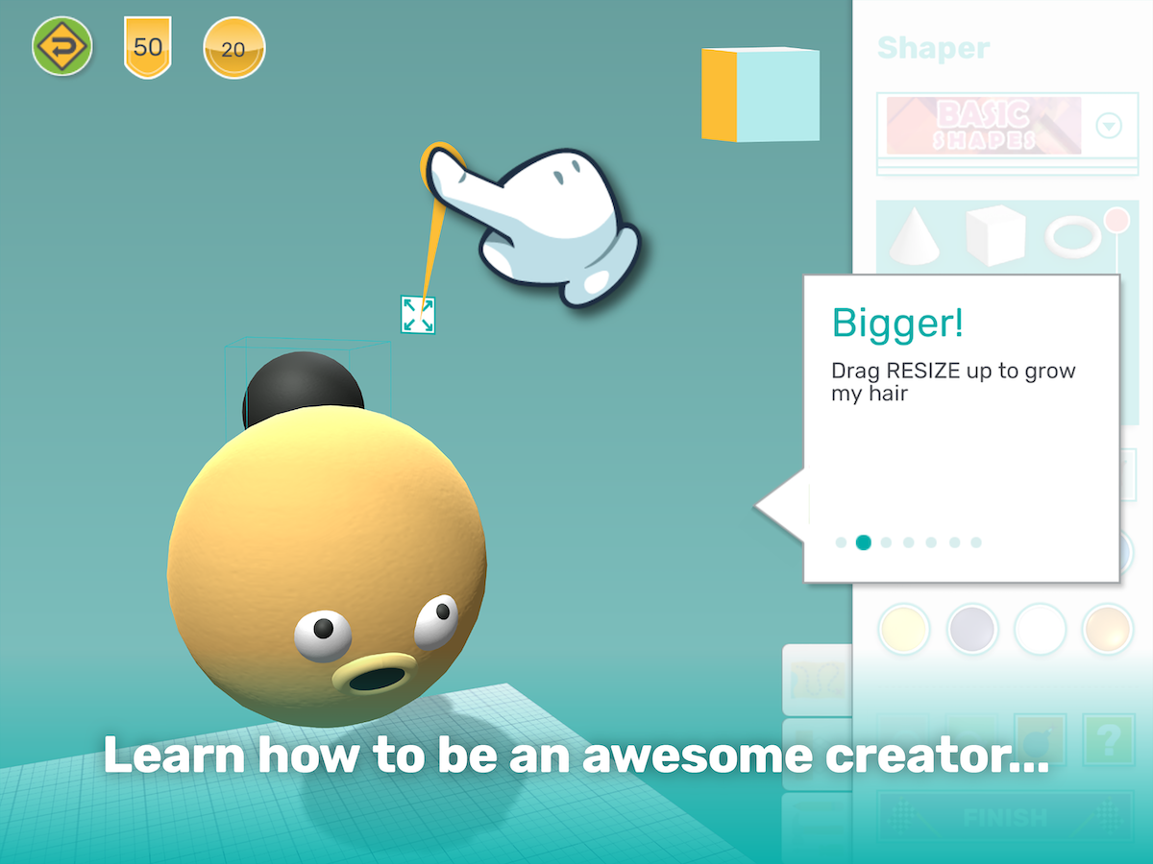
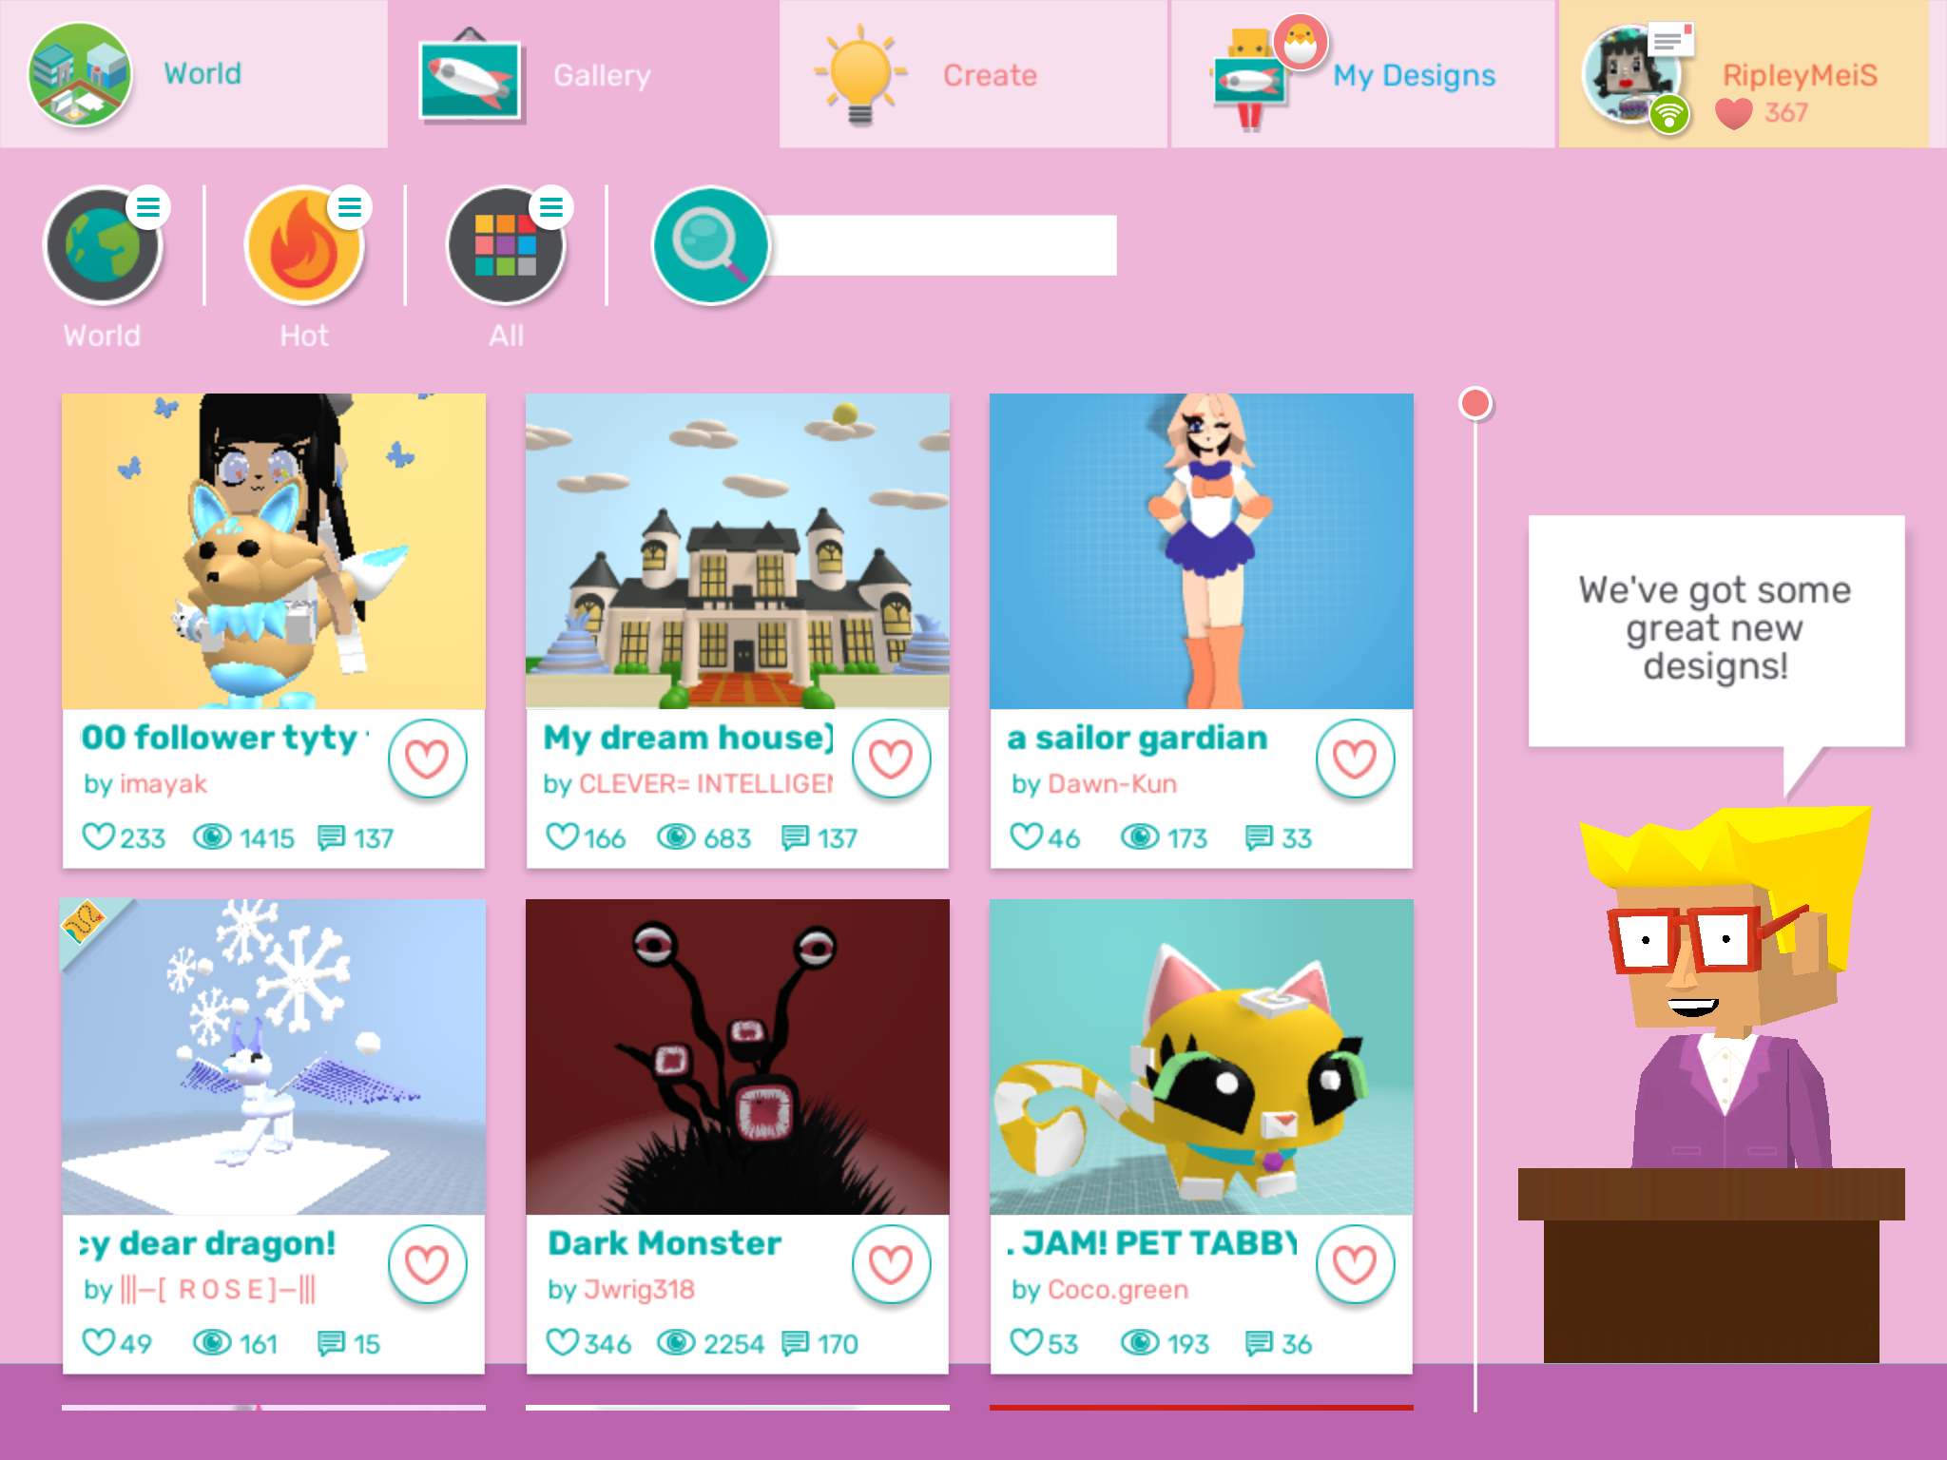
Exciting news! This year, we will be using Makers Empire in our class.

Makers Empire is an award-winning, curriculum-aligned 3D design app and program that our students will use to create anything they can imagine and to design 3D solutions to real-world problems.

Makers Empire is easy to use, and extremely fun and engaging for students. University research shows that students who use Makers Empire typically improve their creative, critical thinking, design thinking and digital skills. Plus, learning how to solve problems and to persist when faced with challenges helps boost their confidence and resilience.

Learning with Makers Empire at Home

The Makers Empire app is free to download and use at home and works on all computers and devices.

Students can use the same account that they do at school so they can share their creations with me and their classmates. Makers Empire school users also have access to special features and content that are not available on free accounts.

If your child forgets their login details, please let me know.

For more information and to download Makers Empire onto your child’s device visit
https://www.makersempire.com/for-parents-guardians

For information about acceptable content and student privacy visit
https://www.makersempire.com/legal-privacy

