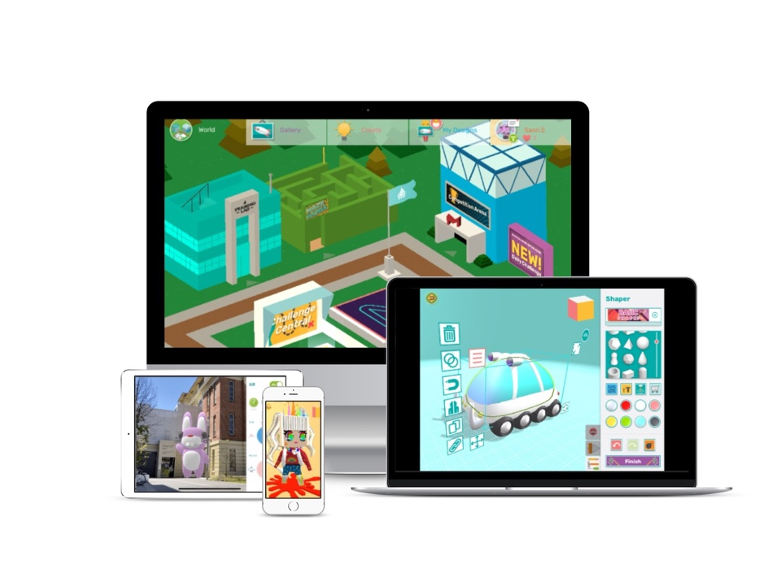

This [year/term - choose relevant one or add your own], we will be introducing Makers Empire to our [grade 4s].

Makers Empire is an award-winning, curriculum-aligned 3D design app and program that students can use to create anything they can imagine and design 3D solutions to real-world problems that can be then printed/prototyped with a 3D printer.

Recent UniSA research shows that Makers Empire improves students’ spatial reasoning (the key indicator for future success in STEM), reduces STEM anxiety and helps close the STEM gender gap in children. Plus, a 12-month Macquarie University research study showed that primary school students who used Makers Empire improved their creative, critical thinking, design thinking and digital skills. Students were highly engaged with the 3D technology and solving genuine design challenges – it helped boost their confidence and resilience when dealing with setbacks.

Unlike free 3D design software/apps, Makers Empire:

- Has been designed specifically for K-8 students;
- Is easier to use, especially for younger students;
- Is extremely fun and engaging; and
- Is accredited by Education Alliance Finland for pedagogical quality.

We’ll be sending a note home with your child(ren) to explain how they can continue learning at home with Makers Empire. The app is free to download and use at home and students can use the same account that they do at school.

For more information and to download Makers Empire onto your family/child’s device visit their Makers Empire website.

