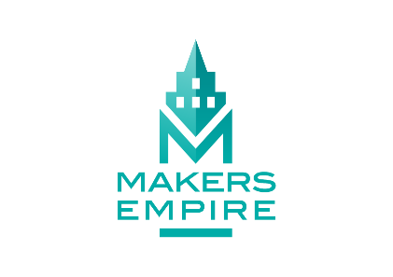

News Release :
ANDY THOMAS SPACE FOUNDATION and MAKERS EMPIRE
JOIN FORCES FOR SCHOOLS PILOT PROGRAM

The Andy Thomas Space Foundation and Makers Empire today announce an Australia-first pilot program for primary schools, to deliver education in awareness of space career opportunities.

As a precursor to a planned national roll-out, the program will be trialled in nine South Australian schools.

The primary schools program, budgeted at $45,000, follows the announcement by the Foundation in March of scholarships at secondary, tertiary and post-graduate levels. Scholarships, with a total value of $150,000, are offered through the ATSF Education Fund, with the support of ATSF’s sponsors and the South Australian Government.

That announcement was the first step in the fulfilment of the Foundation’s vision and objectives.

The new program, for primary schools, will be delivered in terms 3 & 4 this year. It will be a space-themed version of Makers Empire’s Learning by Design course, involving between two and five teachers from each of the participating schools. They will attend a professional development course at Lot Fourteen and design a space education unit for students. The program will culminate in a student-led expo-style Showcase Day on November 22 at the Australian Space Discovery Centre.

Minister for Education John Gardner said this is an exciting opportunity for students. “These young South Australians are part of a generation that will help build our growing space industry and this program will inspire them to shoot for the stars,” said Minister Gardner.
“South Australia is the epicentre of the nation’s space industry, so we are perfectly placed to offer this Australian-first pilot program and encourage children to consider a future that’s out of this world.”

ATSF Chairman Michael Davis AO is delighted with the Foundation’s continuing development of education and awareness programs. “This initiative with Makers Empire brings primary schools into the Foundation’s orbit and it’s an ideal fit with our reason for being which, initially, is about creating educational opportunities and pathways into space-related careers,” he says.

ATSF CEO Nicola Sasanelli AM says the primary schools program is another step towards stretching the Foundation’s influence across the educational spectrum. “In the next weeks we expect to be in a position to name the finalists in the $45,000 High Schools Challenge program, which we announced in March and another initiative is in the pipeline and will be revealed soon. We are also delighted to support an emerging local tech start-up in its endeavours”.

“We expect to be in a position in the next week to name the finalists in the $45,000 Schools Challenge, which we announced in March and another initiative is in the pipeline and will be revealed soon. We are also delighted to support an emerging local tech start-up in its endeavours”.

Makers Empire CEO Jon Soong says his company is delighted to be partnering with the ATSF on the Learning by Design space program for primary schools. “Together we’ll inspire young Australian students with dreams of the stars.”

The schools in this year’s pilot program will be revealed in July.

For further comment or information, please contact :

ATSF Chairman Michael Davis AO - 0419.170251
ATSF CEO Nicola Sasanelli AM - 0488.565938
Christina Soong at Makers Empire - 0409.159074

